CSA1304-THEORY-OF-COMPUTATION
Lab exercises
1.Write a C program to simulate a Deterministic Finite Automata (DFA) for the given
language representing strings that start with a and end with a
code:
#include <stdio.h>
#include <string.h>
int main() {
char str[100];
printf("Enter a string: ");
scanf("%s", str);
int len = strlen(str);
if (str[0] == 'a' && str[len - 1] == 'a')
printf("Accepted\n");
else
printf("Rejected\n");
return 0;
}
Output:
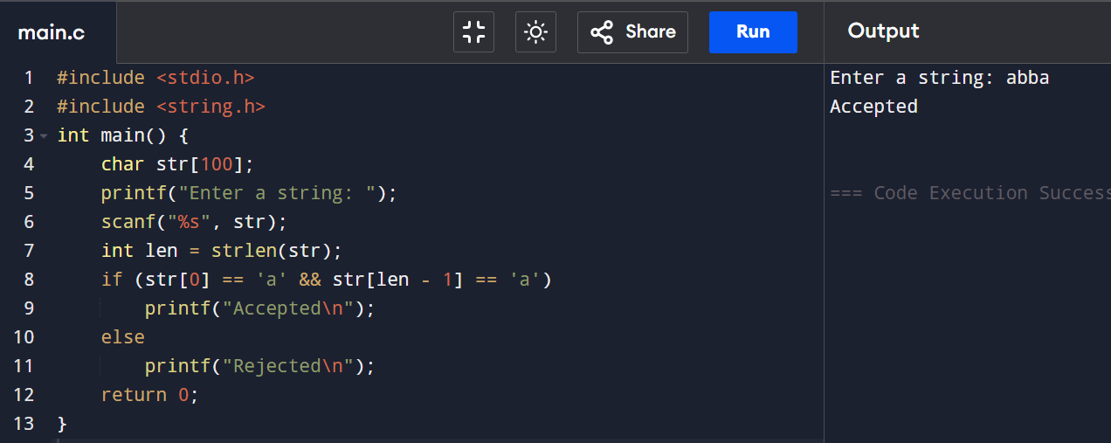
2. Write a C program to simulate a Deterministic Finite Automata (DFA) for the given
language representing strings that start with 0 and end with 1
code:
#include <stdio.h>
#include <string.h>
int main() {
char str[100];
printf("Enter a binary string: ");
scanf("%s", str);
int len = strlen(str);
if (str[0] == '0' && str[len - 1] == '1')
printf("Accepted\n");
else
printf("Rejected\n");
return 0;
}
Output:
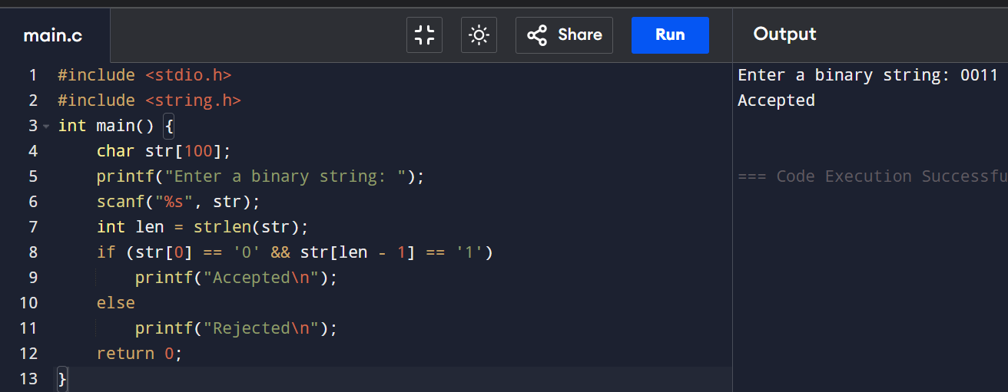
3. Write a C program to check whether a given string belongs to the language defined
by a Context Free Grammar (CFG)
S → 0A1 A → 0A | 1A | ε
Code:
#include <stdio.h>
#include <string.h>
int main() {
char str[100];
int i, valid = 1;
printf("Enter a binary string: ");
scanf("%s", str);
int len = strlen(str);
if (len < 2) {
valid = 0;
}
else if (str[0] != '0' || str[len - 1] != '1') {
valid = 0;
}
else {
for (i = 0; i < len; i++) {
if (str[i] != '0' && str[i] != '1') {
valid = 0;
break;
}
}
}
if (valid)
printf("The string belongs to the language.\n");
else
printf("The string does not belong to the language.\n");
return 0;
}
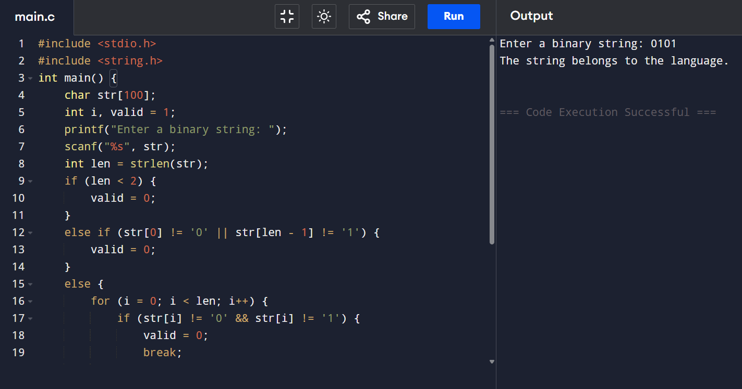

4.Write a C program to check whether a given string belongs to the language defined
by a Context Free Grammar (CFG)
S → 0S0 | 1S1 | 0 | 1 | ε
Code:
#include <stdio.h>
#include <string.h>
int main() {
char str[100];
int i, len, flag = 1;
printf("Enter a binary string: ");
scanf("%s", str);
len = strlen(str);
for(i = 0; i < len; i++) {
if(str[i] != '0' && str[i] != '1') {
flag = 0;
break;
}
}
if(flag) {
for(i = 0; i < len / 2; i++) {
if(str[i] != str[len - 1 - i]) {
flag = 0;
break;
}
}
}
if(flag)
printf("The string belongs to the language.\n");
else
printf("The string does not belong to the language.\n");
return 0;
} output :
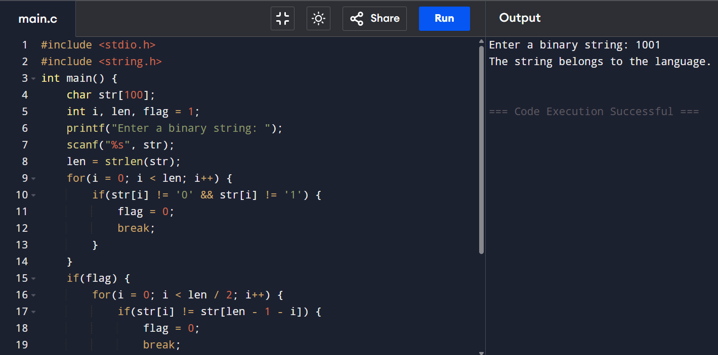
5.Write a C program to check whether a given string belongs to the language defined
by a Context Free Grammar (CFG)
S → 0S0 | A A → 1A | ε
Code:
#include <stdio.h>
#include <string.h>
int main() {
char str[100];
int len, left = 0, right, middleStart, middleEnd;
int valid = 1;
printf("Enter a binary string: ");
scanf("%s", str);
len = strlen(str);
right = len - 1;
while (left <= right && str[left] == '0' && str[right] == '0') {
left++;
right--;
}
middleStart = left;
middleEnd = right;
while (middleStart <= middleEnd) {
if (str[middleStart] != '1') {
valid = 0;
break;
}
middleStart++;
}
if (valid)
printf("The string belongs to the language.\n");
else
printf("The string does not belong to the language.\n");
return 0;}
output:
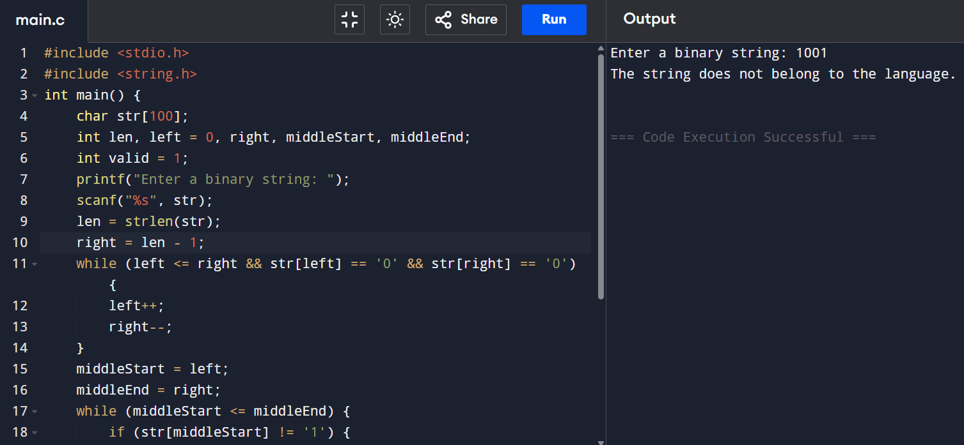
6. Write a C program to check whether a given string belongs to the language defined
by a Context Free Grammar (CFG)
S → 0S1 | ε
Code:
#include <stdio.h>
#include <string.h>
int main() {
char str[100];
int i, len, zeros = 0, ones = 0;
int valid = 1;
printf("Enter a binary string: ");
scanf("%s", str);
len = strlen(str);
i = 0;
while (i < len && str[i] == '0') {
zeros++;
i++;
}
while (i < len && str[i] == '1') {
ones++;
i++;
}
if (i != len)
valid = 0;
if (zeros != ones)
valid = 0;
if (valid)
printf("The string belongs to the language.\n");
else
printf("The string does not belong to the language.\n");
return 0;
}
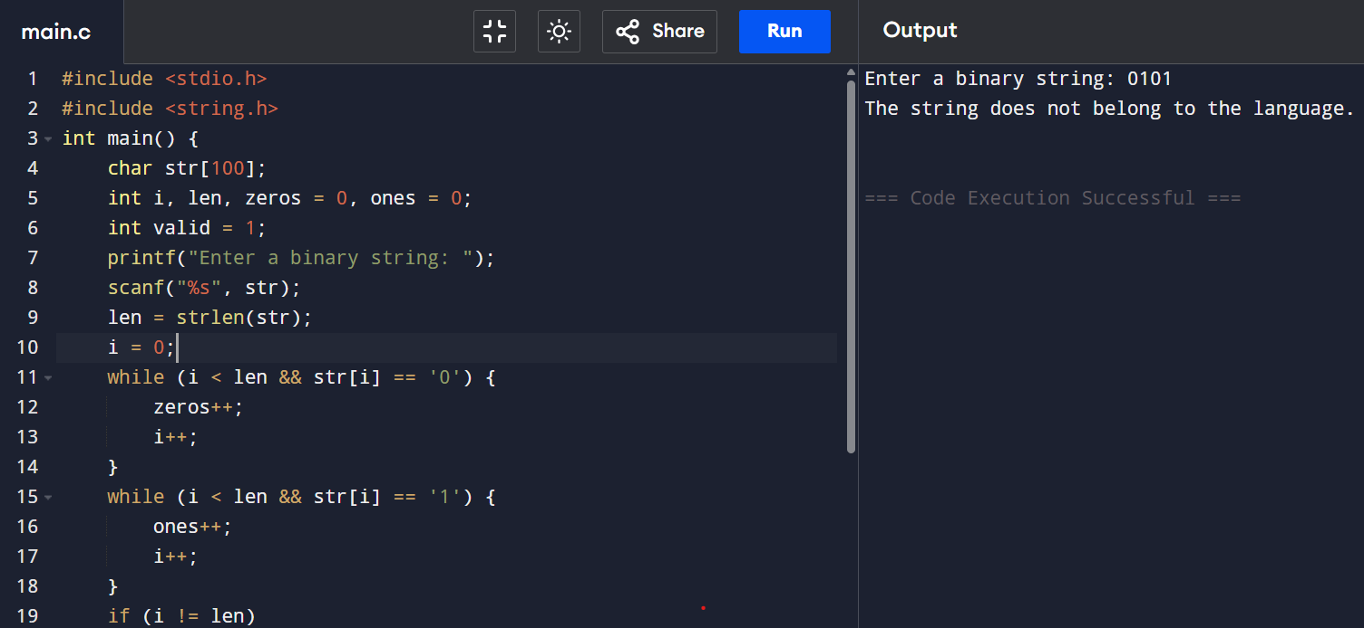
7. Write a C program to check whether a given string belongs to the language defined
by a Context Free Grammar (CFG)
S → A101A, A → 0A | 1A | ε
Code:
#include <stdio.h>
#include <string.h>
int main()
{
char str[100];
int i, len, found = 0;
printf("Enter a binary string: ");
scanf("%s", str);
len = strlen(str);
for(i = 0; i < len; i++)
{
if(str[i] != '0' && str[i] != '1')
{
printf("Invalid binary string.\n");
return 0;
}
}
for(i = 0; i <= len - 3; i++)
{
if(str[i] == '1' && str[i+1] == '0' && str[i+2] == '1')
{
found = 1;
break;
}
}
if(found)
printf("The string belongs to the language.\n");
else
printf("The string does not belong to the language.\n");
return 0;
}
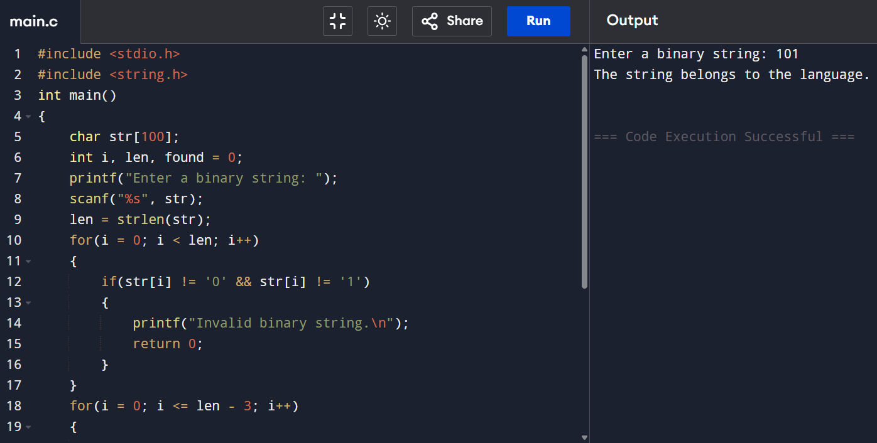
8. Write a C program to simulate a Non-Deterministic Finite Automata (NFA) for the
given languagerepresenting strings that start with b and end with a
code:
#include <stdio.h>
#include <string.h>
int main() {
char str[100];
int len;
printf("Enter the string: ");
scanf("%s", str);
len = strlen(str);
if (str[0] == 'b' && str[len - 1] == 'a')
printf("String Accepted\n");
else
printf("String Rejected\n");
return 0;
}
Output:
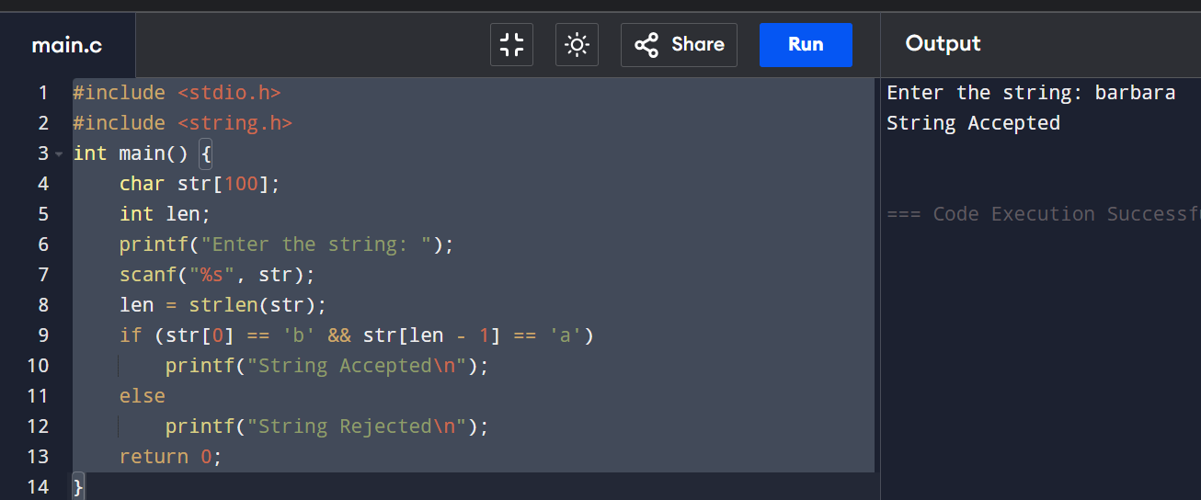
9. Write a C program to simulate a Non-Deterministic Finite Automata (NFA) for the
given language representing strings that start with o and end with 1
code:
#include <stdio.h>
#include <string.h>
int main() {
char str[100];
int len;
printf("Enter a binary string: ");
scanf("%s", str);
len = strlen(str);
if (str[0] == '0' && str[len - 1] == '1')
printf("String Accepted\n");
else
printf("String Rejected\n");
return 0;
}
Output:
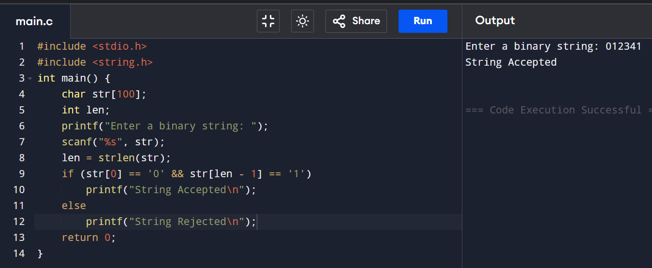
10. Write a C program to find ε -closure for all the states in a Non-Deterministic Finite
Automata (NFA) with ε -moves.
Code:
#include <stdio.h>
int n, e[10][10], visited[10];
void epsilonClosure(int state)
{
int i;
visited[state] = 1;
printf("q%d ", state);
for(i = 0; i < n; i++)
{
if(e[state][i] == 1 && !visited[i])
epsilonClosure(i);
}
}
int main()
{
int i, j;
printf("Enter the number of states: ");
scanf("%d", &n);
printf("Enter the epsilon transition matrix (0/1):\n");
for(i = 0; i < n; i++)
{
for(j = 0; j < n; j++)
{
scanf("%d", &e[i][j]);
}
}

for(i = 0; i < n; i++)
{
for(j = 0; j < n; j++)
visited[j] = 0;

printf("\nEpsilon-Closure(q%d) = { ", i);
epsilonClosure(i);
printf("}");
}
return 0;}
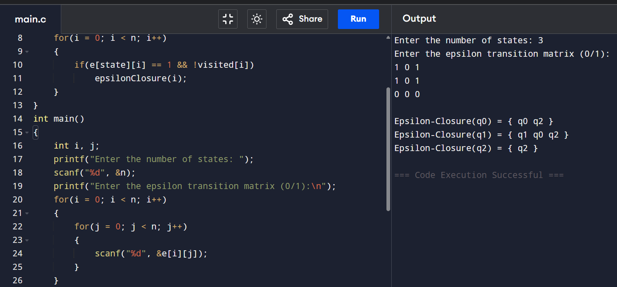
11. Write a C program to find ε -closure for all the states in a Non-Deterministic Finite
Automata (NFA) with ε -moves.
Code:
#include <stdio.h>
int n, e[10][10], visited[10];
void epsilonClosure(int state)
{
int i;
visited[state] = 1;
printf("q%d ", state);
for(i = 0; i < n; i++)
{
if(e[state][i] == 1 && !visited[i])
{
epsilonClosure(i);
}
}
}
int main()
{
int i, j;
printf("Enter number of states: ");
scanf("%d", &n);
printf("Enter epsilon transition matrix (0/1):\n");
for(i = 0; i < n; i++)
{
for(j = 0; j < n; j++)
{
scanf("%d", &e[i][j]);
}
}
for(i = 0; i < n; i++)
{
for(j = 0; j < n; j++)
visited[j] = 0;
printf("\nEpsilon-Closure(q%d) = { ", i);
epsilonClosure(i);
printf("}");
}
return 0;}
output:


